Picture and story books to support transition into school

There are plenty of picture books that can prepare your little ones for their start at ‘big school’ and help them to talk about and dispel any worries or fears they may have. Here is a selection of some of our favourites:

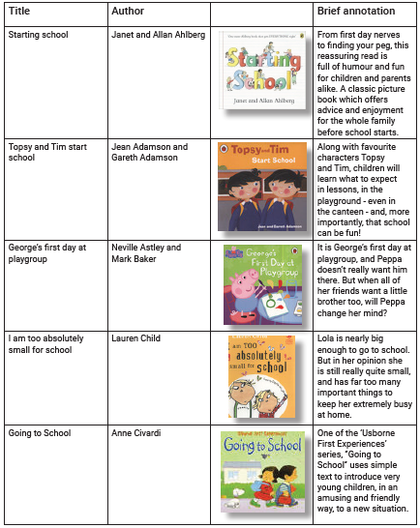

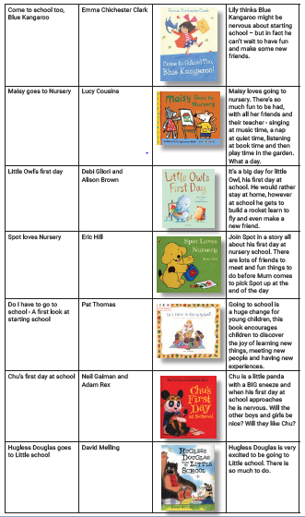
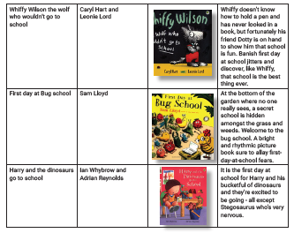

You can access all of these wonderful books and more for free by becoming a member of a local library. Please see their website for more information: https://llc.ent.sirsidynix.net.uk/client/en_GB/luton/?

If you are not able to access copies of these books, why not try searching for them on YouTube instead, or better still try to find them on the Luton online library? (details below).

Sharing and enjoying stories with your child is one of the most important things that you can do to support their development. It helps them to build their language, literacy and communication skills and develop a real love for reading!

You can sign up to become a member of the library either online or in person. There is an amazing range of e-books available for you to access in the online library, including e-stories, audiobooks, e-magazines and much, much more!

Join the library today: https://llc.ent.sirsidynix.net.uk/client/en_GB/luton/?

