Catholic Diocese of Northampton

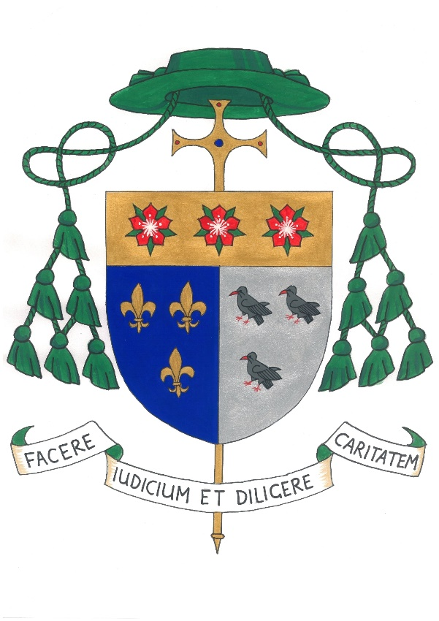
Inspection Report of Denominational
Character and Religious Education

(Under Section 48 of the Education Act 2005)
ST MARGARET OF SCOTLAND CATHOLIC
PRIMARY SCHOOL
Rotheram Avenue, Luton, LU1 5PP

DfS School No: 821/3355
URN: 109634

Headteacher: Mrs G Somes
Chair of Governors: Mr M Moore

Reporting Inspector: | Mrs R Jones
Associate Inspector: | Mrs K Williams
Date of Inspection: | 27 June 2018
Date Report Issued: | 6 July 2018
Date of previous Inspection: | January 2013

The School is a member of St Alban’s Academy Trust
in the Trusteeship of the Diocese

Information about the School
St Margaret of Scotland school is a large primary school with 575 pupils on roll, of whom 62% are baptised Catholics. The school serves three parishes in Luton, St Margaret of Scotland, Our Lady Help of the Christians and Holy Ghost. 39% of the teaching staff are Catholic and 39% of support staff are also Catholic. The number of pupils from ethnic minority backgrounds is increasing and across the school is currently 54% with over 20 languages spoken. 12% of all pupils have SEN and 19% of pupils are in receipt of pupil premium grant.

Key grades for inspection
1: Outstanding 2: Good 3: Satisfactory 4: unsatisfactory

Overall effectiveness of this Catholic school Grade 2
St Margaret of Scotland is a good school with some outstanding features. Under the strong leadership of the headteacher and Religious Education subject leader, the Catholic ethos and identity is given high priority and is well supported by all staff. One of the strengths of the school is the effectiveness of the headteacher who has a clear vision for improvement ably supported by the SLT. The behaviour of the pupils is outstanding; they enjoy their learning and are proud to be part of the school community. Overall teaching is good. Parents expressed similar strong support. The school provides a good Religious Education curriculum. Since the last inspection there have been many staffing changes.

The school’s capacity for sustained improvement Grade 2
The school has a good capacity for sustained improvement. After a period of many staff changes there is now a stable staff and leadership team who are well placed to move the school forward. The school is continuing to work on raising attainment in Religious Education. This was identified as an area for development at the last inspection. Strategies are now in place to record pupil responses to the provision for the Catholic life in the school, which was also identified as an area for development at the last inspection. A robust monitoring system is now in place which enables leaders to identify areas for improvement. A high profile is given to Religious Education and leaders have put in place strategies to share good practice and support new and non-Catholic staff. The senior leadership team and governors have a clear vision for the Catholicity of the school.

The RE subject leader and headteacher are good role models for staff. They provide opportunities for staff development both within the school and by attending diocesan training. Regular moderation of work with other schools in the St Albans Catholic Academies Trust ensures staff have a better understanding of assessment and attainment. The school is currently piloting the proposed changes to primary Religious Education assessment.

The school’s self-evaluation is accurate and the inspectors concur with the judgements made by the school. The headteacher has a sound understanding of the school’s strengths and developmental needs and is very well supported by the RE subject leader. Governors play an active part in the life of the school and are frequent visitors.

What the school should do to improve further:

- continue to develop high quality teaching in Religious Education especially in terms of pace and challenge, thereby ensuring that all pupils make at least good progress
- work to ensure consistency of presentation of written work across each year group and across the school.

Outcomes for pupils Grade 2
Pupils benefit greatly from the Catholic life of the school. They can articulate clearly what is special about St Margaret of Scotland school, about belonging to “God’s Family” and about caring for all. Pupils are proud of their school. They take on responsibilities for developing the Catholic nature of the school, leading prayer, providing lunchtime prayer groups and being good role models for others. During the inspection pupils spoke about how they try to ensure everyone is included. The anti-bullying committee (ABC) presentation in assembly clearly demonstrated their care and concern for others. Pupils fully appreciate how they are growing to be responsible citizens and how they are called to serve others. This is put into practice by the charitable work they undertake, fundraising for CAFOD, the local Food Bank, Noah and the NSPCC.

Prayer forms an important part of the daily life of the school. Pupils engage in prayer and collective worship readily and with reverence. There is a prayer focus in each classroom and there are opportunities for reflection and to write their own prayers. These are on display to share with others. Pupils know the traditional prayers. During the inspection, inspectors saw good examples of class prayer using relevant music and images.

Chaplaincy provision is outstanding and makes a significant contribution to the well-being of pupils and the wider school community. The chaplaincy team work together to promote the spiritual development of pupils, the Catholic life of the school and to provide support to all pupils, staff and parents. The Religious Education governor informed the inspectors about the tremendous support she and her child were given following a recent bereavement. Pupils know where to go and what to do when they need help. They feel valued and respected.

Achievement and progress in Religious Education is good with most pupils making good progress. Pupils enjoy their lessons, show interest and work diligently. Many pupils enter the school with standards below those expected for their age. However, good progress is evidenced by the year 6 pupils’ work, confidence and achievement. Most pupils can explain their learning, the topics covered and how these relate to their own lives. The quantity of work in pupils’ books is good. Lessons are well planned with clear differentiation. Improved pace and challenge in lessons would encourage more independent learning and improved progress. Behaviour in lessons and around the school was outstanding.

Leadership and management Grade 1
The headteacher, RE subject leader and governors are highly effective in ensuring the school maintains a very strong Catholic identity. All are ambitious for the school and are working hard to raise standards. There are excellent relationships between the headteacher, SLT and governors. They know their community and their children very well and as a result they are highly informed about standards, strengths of the school and areas for development. The relationships between pupils and staff is very good, pastoral care is outstanding. Pupils feel supported and appreciate the care and attention provided to them. They say all staff listen to them, help them and provide good activities to help and encourage their learning. The wider curriculum is varied and provides opportunities for spiritual experiences. Pupils are fully involved and parents are kept informed through regular newsletters and through invitations to attend events.

The subject leader has a clear programme for monitoring teaching and learning. A Religious Education handbook has been created to support staff and share knowledge of the Catholic faith across the school. Learning walks are undertaken regularly in which governors also take part. The monitoring of pupils’ books with feedback provided to staff is undertaken as part of the monitoring and evaluation process within the school. Governors are clearly very committed to their role and have a very good overview of the work of the school. This enables them to challenge and question effectively.

The head teacher and senior staff of St Margaret’s are proud to lead a fully inclusive school, where all respect and value diversity. This is evident in the attitudes and behaviour of the pupils. The pupils were a joy to be with and could give many examples of how they work together, enjoy learning about their own and other faiths and raise funds for a range of charities and good causes.

Provision Grade 2
The provision for the prayer life and collective worship is good. Chaplaincy provision is outstanding. The chaplaincy team meet regularly and have a designated display board in the school. Chaplaincy is accessible to parents who have access to a family worker who supports the most vulnerable. The team work closely with other chaplaincy teams in the St Albans partnership of schools sharing good practice and provision. Since 2016 years 2 and 6 have benefitted from a 1 day retreat. There are good links between the school and the parishes they serve. Local clergy visit regularly and mass is celebrated in school. Faith Ambassadors work with the local parishes to provide “Tasty Treat” afternoons for the elderly. Each classroom has a prayer focus with religious artefacts and a display board which includes children’s work. Staff and pupils regularly pray together. Displays around the school reflect the current Religious Education topic. The Faith Ambassadors play an active part in the prayer life of the school often leading lunchtime prayer groups, assemblies and liturgies.

The quality of teaching and learning is generally good. However, there are some inconsistencies across the school. Where teaching is good, pupils are keen to learn, enjoy their work and concentrate well. These lessons were well planned and delivered with enthusiasm. In lessons where teaching is less good children were passive in their learning and did not make sufficient progress due to lack of pace and challenge. The Religious Education subject leader and SLT are aware of this and have put in place a programme of model lessons to improve the quality of teaching. Scripture is used well in the classroom. Teaching assistants are well utilised and support children effectively. Formal assessments are undertaken termly and used to inform planning. The quality of work and presentation in the children’s workbooks varies across the school. Work is generally well marked with some suggesting ways to improve.

The quality of the Religious Education curriculum is good and provides a good coverage of topics with a range of learning tasks and differentiated methods of recording outcomes. At least 10% of curriculum time is devoted to the subject. Pupils are enabled to become aware of their responsibilities to each other and the environment. The curriculum contributes well to their spiritual and moral development and raises pupils’ awareness of other faiths. Good and imaginative use is made of resources.

The inspectors wish to thank the headteacher, staff and children for their warm welcome and helpfulness during the inspection.

