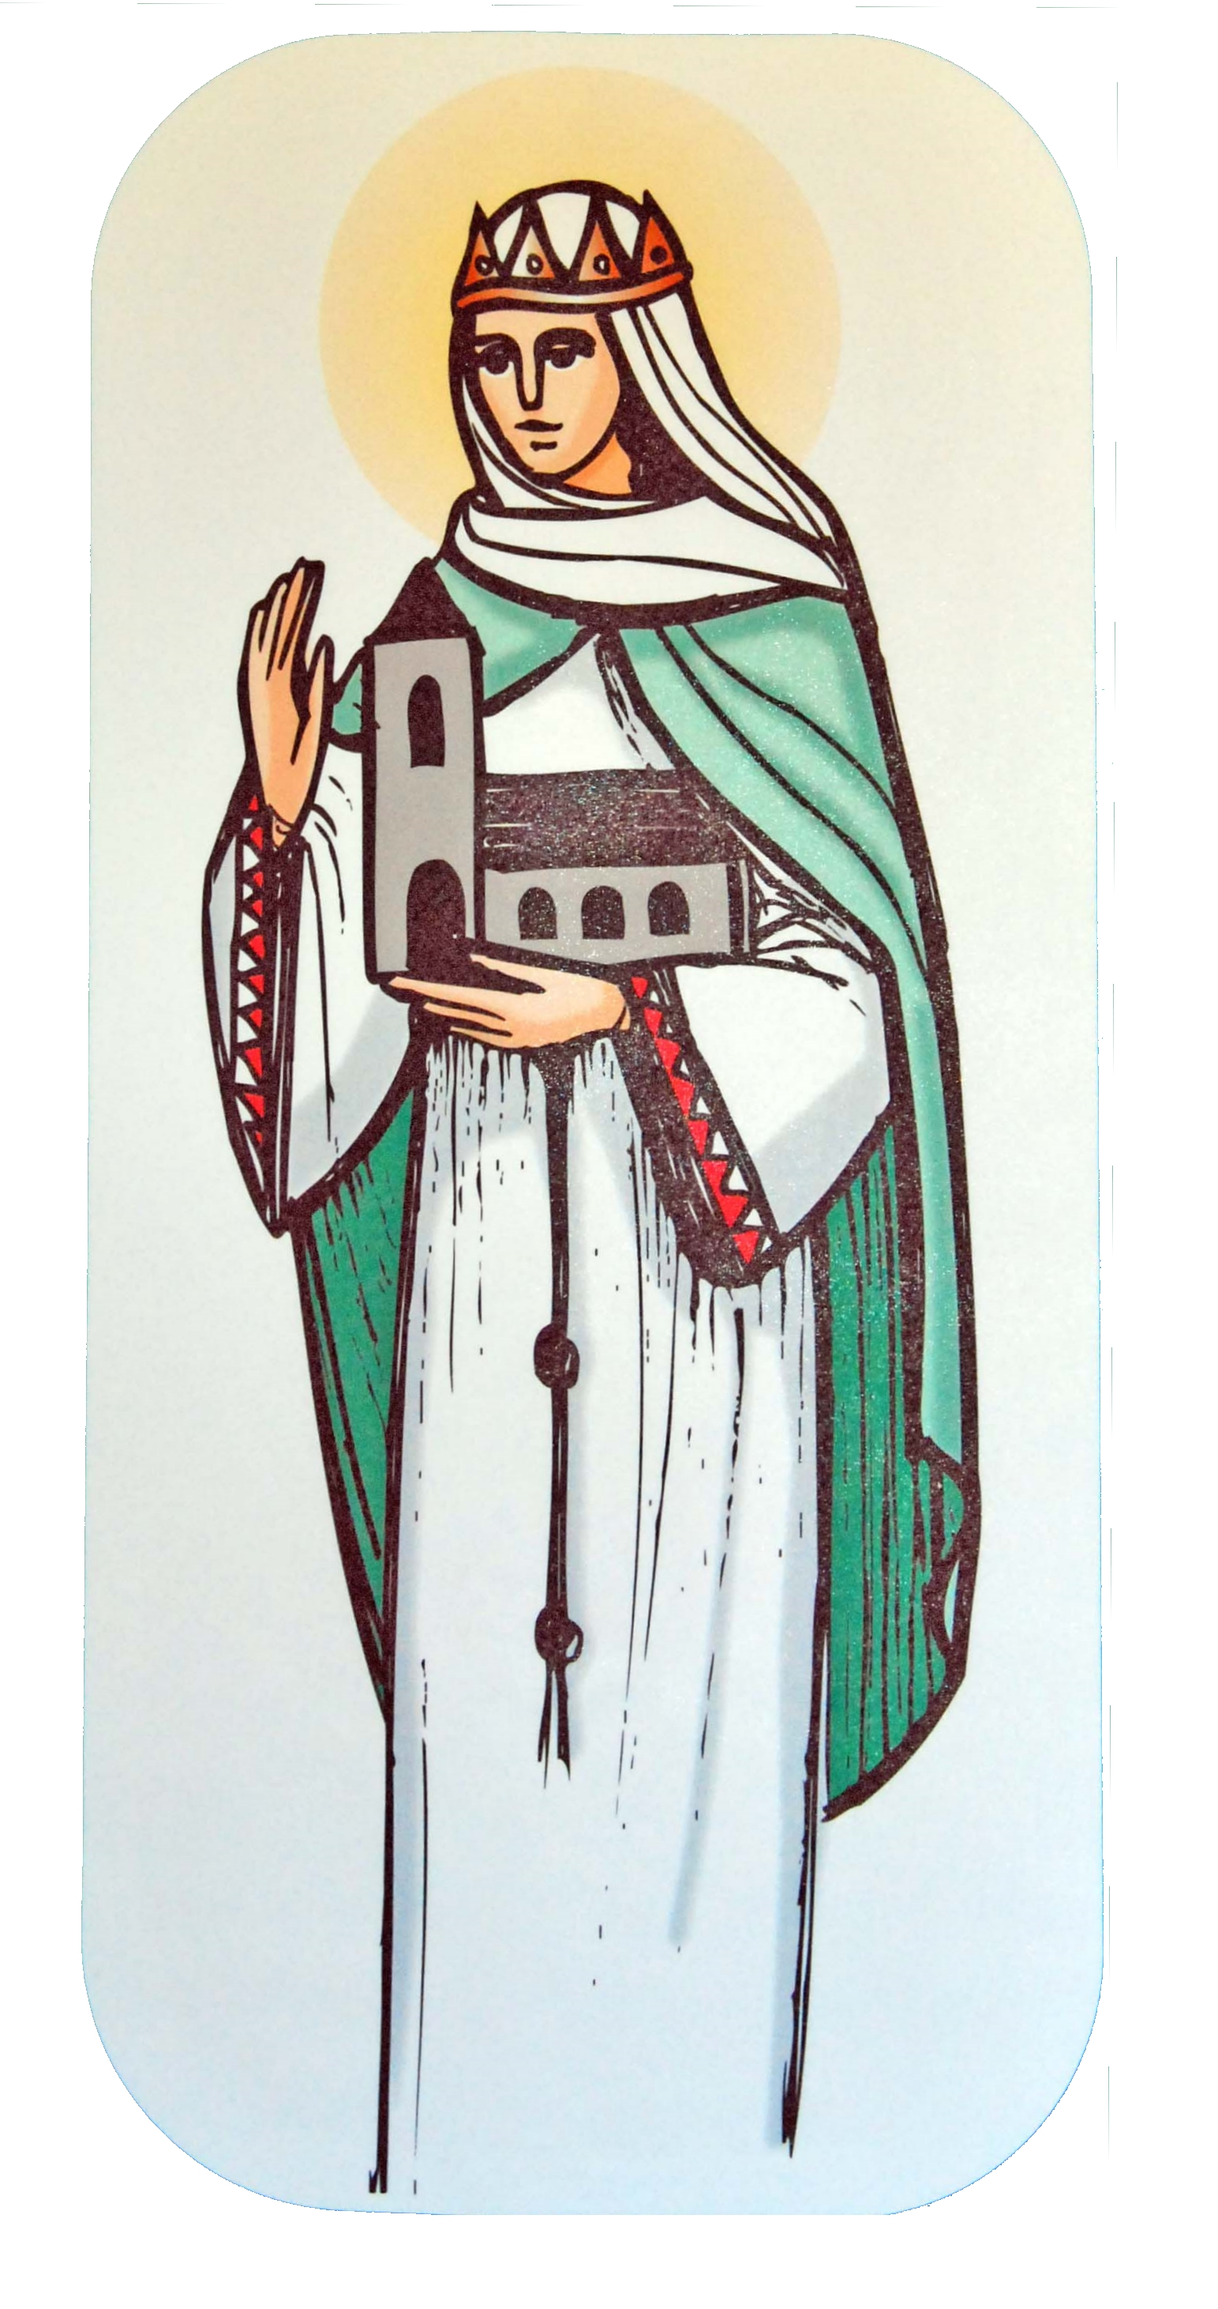

St Margaret of Scotland Catholic
Primary School

RE Curriculum Newsletter
Lent Term
8th January – 29th March 2024

St Margaret of Scotland Catholic
Primary School
This term we will be studying the three themes of Local Church (Community), Eucharist (Relating) and Lent/Easter (Giving). Each class will approach the themes through different topics.

Local church - community  Yr 1 special people - People in the parish family  Yr 2 Books - The books used in Church  Yr 3 Journeys - Christian family’s journey with Christ  Yr 4 Community - Life in the local Christian community and ministries in the parish  Yr 5 mission - Continuing Jesus’ mission in diocese (ecumenism)  Yr 6 sources - the Bible, the special book for the Church | At home  Explore the Diocesan website, looking at the number of churches, and finding out about our bishop.  Read Bible stories together or encourage older children to read a child’s Bible.  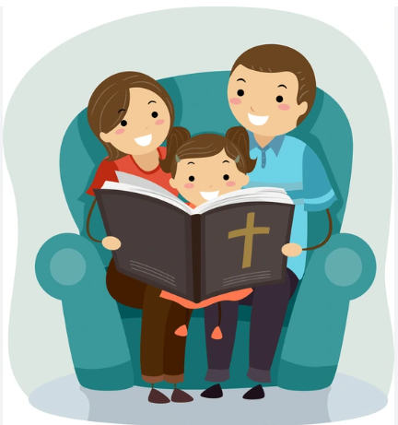
Eucharist - Relating  Yr 1 meals - Mass, Jesus’ special meal  Yr 2 thanksgiving - Mass, a special time to thank God  Yr 3 listening & Sharing - Jesus gives himself to us  Yr 4 giving & receiving - Living in communion  Yr 5 memorial Sacrifice - Eucharist as the living memorial of Christ’s sacrifice  Yr 6 unity - Eucharist enabling people to live in communion | At home  Look through the family photograph album to help the children remember important events and special people in their lives.  Discuss how we come together for special celebrations.  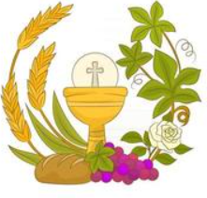
Lent/easter - giving  Yr 1 change - Lent: a time for change  Yr 2 opportunities - Lent: an opportunity to start anew  Yr 3 giving all - Lent: remembering Jesus’ total giving  Yr 4 self discipline - Celebrating growth to new life  Yr 5 sacrifice - Lent: a time of aligning with the sacrifice made by Jesus  Yr 6 death & new life - Celebrating Jesus’ death and resurrection | At home  As a family talk about how you are going to practice self-control and self-giving for the rest of the season of Lent. You may decide to give up biscuits or cakes and donate the money to a charity.  If you have an older child provide him/her with an opportunity to take part in The Stations of the Cross. Ask your child/ren how the school is focusing on Lent and self-giving.

Early Years Foundation Stage
Pupils in our Early Years Foundation Stage will be introduced to the new Religious Education Directory materials as follows:
Lent term 1 – GALILEE TO JERUSALEM  Lent term 2 – DESERT TO GARDEN | Jesus came to show God’s love and welcomes everyone  Easter celebrates that Jesus is with us still

Special days this term  You are welcome to join us for your child’s class assembly at 8.30am | Jan 18th 5 St Francis Assembly – for parents  Jan 23rd Yr2 Retreat Day  Jan 25th 4 St Bernadette Assembly - for parents  Feb 1st 4 St Francis Assembly - for parents  Feb 2nd Yr 3 to First Friday Mass in church  Feb 14th Ash Wednesday Mass – Yrs 4,5 & 6 in church  Feb 15th 3 St Bernadette Assembly - for parents  Feb 27th Yr3 Stations of the Cross in church  Feb 28th - Service of Reconciliation – KS1 and KS2 followed by individual confessions for Y4,5,6  March 1st Yr 2 to First Friday Mass in church  March 4th – Meditation Monday – for parents  March 5th Yr4 Stations of the Cross in church  March 6th Yr 5 Stations of the Cross in church  March 7th 3 St Clare Assembly - for parents  March 12th Yr6 Stations of the Cross in church  March 13th – Adoration of the Blessed Sacrament – in school for Yr 6  March 14th 5 St Clare Assembly - for parents  March 18th Easter Service at St. Margaret’s Church – all welcome  March 26th Tasty Treats – for grandparents
Important dates for the Church this term: | Jan 1st Mary, the holy mother of god  Jan 7th The Epiphany of the Lord  Jan 8th The Baptism of the Lord  Feb 2nd The Presentation of the Lord  Feb 14th Ash Wednesday  March 19th St Joseph, spouse of the Blessed Virgin Mary  March 24th Palm Sunday  March 28th Maundy Thursday  March 29th Good Friday  March 31st easter Sunday
LENT
Lent is a time not only for abstinence but also a time to think of others and become closer to God through prayer.


Try to take some time each day to pray together as a family.

