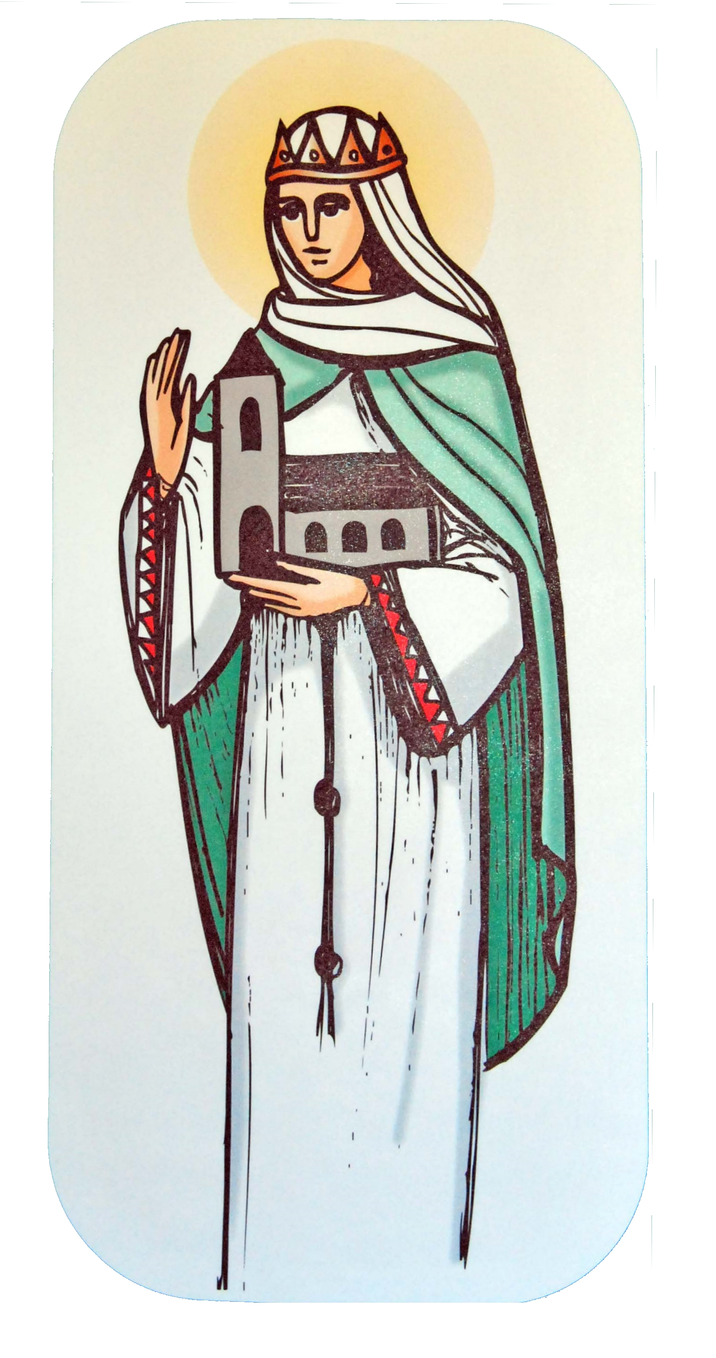

St Margaret of Scotland Catholic
Primary School



RE Curriculum Newsletter
Advent Term
4th September – 20th December 2023

St Margaret of Scotland Catholic
Primary School
This term we will be studying the three themes of Domestic Church (Family), Baptism and Confirmation (Belonging) and Advent and Christmas (Loving). Each class will approach the themes through different topics. The children will also spend a week studying Judaism.

Domestic Church – Family  Yr1 Families – God’s love and care for every family  Yr2 Beginnings – God is present in every beginning  Yr3 Homes – God’s vision for every family  Yr4 People – The family of God in Scripture  Yr5 Ourselves – Created in the image and likeness of God  Yr6 Loving – God who never stops loving | At home  Look through your family photo album. Try to find photos of all the significant family members – grandparents, parents, children, aunts, uncles etc. who show God’s love.  
Baptism and Confirmation - Belonging  Yr1 Belonging – Baptism: an invitation to belong to God’s family  Yr2 Signs and Symbols – Signs and symbols in Baptism  Yr3 Promises – Promises made at Baptism  Yr4 Called – Confirmation: a call to witness  Yr5 Life Choices – Marriage, commitment and service  Yr6 Vocation and Commitment – The vocation of priesthood and religious life | At home  Talk to someone who has been to a Baptism and/or Confirmation about their memories of this celebration.  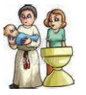
JUDAISM
Pupils will study various aspects of Judaism for one week. Ask them what they have been learning about.
Advent/Christmas - Loving  Yr1 Waiting – Advent: a time to look forward to Christmas  Yr2 Preparations – Advent: preparing to celebrate Christmas  Yr3 Visitors – waiting for the coming of Jesus  Yr4 Gift – God’s gift of love and friendship in Jesus  Yr5 Hope – Advent: waiting in the joyful hope for Jesus, the promised one  Yr6 Expectations – Jesus born to show God to the world | At home  Discuss with the children how your family welcomes visitors to your home. Find out about some Christian symbols for Advent, e.g. Advent wreath, calendar, Jesse tree. Use the CAFOD (http://www.cafod.org.uk/)  or Missio (http://www.missio.org.uk/ websites to get a religious Advent calendar.

Early Years Foundation Stage
Pupils in our Early Years Foundation Stage will be introduced to the new Religious Education Directory materials as follows:
Advent term 1 – Creation and Covenant  Advent term 2 – Prophecy and Promise | God knows and love each one of us  God sent Jesus to love us all
Judaism – The celebration of Hanukkah | Pupils will study Judaism for one week.

Special days this term  You are welcome to join us for your child’s class assembly at 8.30am | Sept 10th Education Sunday  Sept 11th Catholic Schools Week  Sept 27th New School Year Mass – Years 4, 5 & 6  Oct 6th – Diocesan Mass at St. Mary’s, Dunstable – Faith Ambassadors and selected pupils  Nov 3th – First Friday Mass at St. Margaret’s Church – Year 5  Nov 9th 6 St Clare Assembly – for parents  Nov 16th St Margaret of Scotland Feast Day Mass at Church – Years 4, 5 and 6  Nov 23rd 6 St Francis Assembly – for parents  Nov 30th 6 St Bernadette Assembly – for parents  Dec 1st – First Friday Mass at St. Margarets Church – Year 4  Dec 5th – Adoration of the Holy Sacrament – in school for KS2  Dec 6th - Service of Reconciliation – KS1 and KS2 followed by individual confessions for Y4,5,6  Dec 11th – Meditation Monday – for parents  Dec 12th – Christmas Service at St. Margaret’s Church – all welcome  Dec 18th – Tasty Treats – for grandparents
Important dates for the Church this term: | Nov 1st All Saints  Nov 2nd All Souls  Nov 26th Christ the King  Dec 3rd Advent begins  Dec 8th The immaculate conception of the Blessed Virgin Mary  Dec 25th The Nativity of the Lord  Dec 31st The Holy Family of Jesus, Mary and Joseph
ADVENT
Advent means ‘coming’. We think of the coming of Jesus when he was born but we also think of his promise that he would come again at the end of time. It is a time of waiting and preparing. It is only during the last week of Advent that we focus upon the events to be celebrated at Christmas.
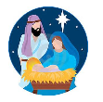
Try to take some time each day to pray together as a family.

