

ST MARGARET OF SCOTLAND

CATHOLIC PRIMARY SCHOOL

Attendance & Leave of Absence Policy

September 2022

SECTION 1: POLICY

The law states that a pupil is required to attend regularly at the school where he, or she, is a registered pupil.

Regular school attendance and punctuality are extremely important, valuable learning time is lost when pupils are absent or late. Pupils need to attend school regularly if they are to take full advantage of the educational opportunities available to them. The school’s ethos demonstrates that children feel that their presence in school is important, that they are missed when they are absent or late. The school will take appropriate action when necessary in order to promote the aims of the policy.

Aims:

- To maximise attendance of all children.
- To provide an environment which encourages regular attendance and makes attendance and punctuality a priority for all those associated at the school.
- To monitor and support children whose attendance is a cause for concern, and work in partnership with parents and carers to resolve any difficulties.
- To analyse attendance data regularly to inform future policy and practice.
- To work closely and make full use of the support from the wider community including the Education Welfare Service and multi-agency teams.

SECTION 2: ATTENDANCE GUIDANCE

Responsibilities of Parents and Carers:
By law Parents are responsible for ensuring children attend school regularly and punctuality rests with parents. However, where school attendance problems occur, the key to resolving these problems is engaging the child through collaborative working between the parent, the school and the Local Authority.

Parents should:

- Ensure their children attend school regularly.
- Ensure they are punctual for school.
- Ensure they are appropriately dressed and in a condition to learn.
- Comply with the attendance policy.
- Make sure their child understands the reasons for good attendance and punctuality.
- Make sure appointments are made outside of school hours wherever possible and show evidence of the appointment when it is not.
- Notify the school on the first day of their child’s absence by 9.00am.
- Follow the procedure for term time holidays.
- Work in partnership with the school.

Responsibilities of the school

The school will:

- Have a registration system that is accurate, informative and understood.
- Analyse data regularly and identify the actions that need to be taken.
- Follow up unexplained absences promptly.
- Ensure that attendance and punctuality have a high profile in our communications with parents.
- Have clear written guidance for parents.
- Promote good attendance and punctuality for all.
- Work in partnership with families and the Educational Welfare Service.
- Inform parents of their child’s attendance regularly during the school year.
- Set and monitor progress towards annual targets for attendance.
- Evaluate the effectiveness of the Attendance Policy.

Responsibilities of the Educational Welfare Service

The Education Welfare Service will:

- Monitor registers regularly.
- Identify children/families with attendance difficulties.
- Agree time limited action which needs to be taken by the school or Education Welfare Officer.
- Feedback on the progress of cases and exchange of information.
- Issue penalty notices where applicable.
- Provide advice to the school.
- Work in partnership with the school and families.

SECTION 3: SCHOOL PROCEDURES

- The School uses Attendance Manager provided by SIMS to store and monitor its legal responsibilities in relationship to attendance. This system consists of specialised software.

- Registers are a vital legal document and teachers are required by their contractual duties to take an attendance register at the beginning of both the morning and afternoon sessions.

- Registers must be completed carefully and accurately, as they provide a record of a child’s attendance. Failure to complete a register accurately leaves the school vulnerable to complaint from parents or carers and constitutes a risk if an emergency evacuation has to take place.

Absence
Parents and Carers can be taken to court if they do not make sure their child attends school, without reason (as defined in law) and if the child has too many unauthorised absences.

Illness

- Parents/carers are asked to contact the school before 9.00am each day that their child is absent providing the reason for the absence, to give an update on how the child is and when the child is likely to return to school.

- Where the school Attendance Officer is not made aware of the reason for a child’s absence they will contact parents/carers by telephone on the first day of absence by 10.00am.

- If there is any concern surrounding an absence or if school are not able to make contact with a parent then a home visit will be considered.

- If any member of staff is concerned about a reason for absence, the Head Teacher or Senior Leadership Team should be informed.

- In the event of continued sickness, parents are advised to provide information from a relevant practitioner. This keeps pastoral and attendance staff informed of the pupil’s needs and appropriate support can then be arranged where necessary.

See Appendix 1 for School Absence Procedures.

Medical or Dental Appointments
Pupils must not leave the school premises during the school day without permission from the Head Teacher in consultation with the parents. Routine medical or dental appointments are discouraged in school time because of the disruption that they cause. However, where appointments in school time are absolutely necessary, pupils are encouraged to attend school for part of the day depending on the time of the appointment.

- Absence from school due to a medical or dental appointment will be considered as an authorised absence. Parents should inform the school in advance and show the letter or appointment card as evidence.

- Parents/carers are encouraged to make all medical appointments out of school hours.

Improving Poor Attendance
The regular monitoring and analysis of school registers enables patterns and trends to be identified. See Appendix 4 for school monitoring procedures.

Children who are subject to either a Child Protection or Child In Need Plan (CIN), children who are in public care (LAC) and Young Carers attendance are prioritised each day for absence phone calls and reporting. This is the responsibility of the Attendance Officer who will report directly to the Deputy Head and Family Workers with any concerns.

96% and below
If attendance drops below 96% the Attendance Officer will inform parents with a letter (Appendix 5) advising them that their child’s attendance/punctuality will be monitored for the next four weeks. Parents are able to meet the Family Worker, Attendance Officer or Deputy Head Teacher to discuss this further.

90% and below
If attendance drops below 90% the child is classed as a ‘Persistent Absentee’, the Educational Welfare Officer will be informed and parents will be invited to a meeting with the Attendance Officer/Family Worker and in some cases the Deputy Head.

85% and below
If attendance is below 85% the child continues to be classed as a ‘Persistent Absentee’, at this stage the Education Welfare Officer will meet with parents. Fixed penalties may be incurred with the possibility of prosecution where no significant improvement is evident.

The aim throughout this process is to ensure all children have the best attendance possible. The school will work in partnership with parents and individual circumstances will be taken into account, applying the process accordingly.

A visit to families at home will be conducted where necessary.

Lateness
All parents are responsible for their child’s travel arrangements to school and to ensure their child arrives on time. Even children coming from some distance are therefore expected to be on time. Children are marked late if they are in school before the end of registration but were not present when their name was called.

School hours are from 8.30am until 3.00pm Monday to Friday. The school does not take responsibility for children on site prior to 8.15am unless they are attending the Wraparound Club. Children must not stay on site after 3.00pm, unless they are taking part in an organised school activity.

- Children must arrive at school between 08:15am and 08:25am.

- Children arriving after the gate has been closed at 08.25am must enter school through the School Office.

- Children arriving after 8.30am will be registered late.

- Children arriving after 9:00am after the register closes will be recorded as an un-authorised late unless a satisfactory reason is given, for example a medical appointment.

- Lateness is monitored by the school Attendance Officer/Family Workers.

- Action to address lateness will be taken in line with the school’s strategy to improve punctuality – see below.

- We expect parents and carers to collect their child promptly at the end of the school day as it is upsetting for children if they do not. Children who are not collected within 15 minutes of the end of the school day are brought to the school office and parents contacted. Where children are collected late from school persistently, parents will be asked to meet with the school Attendance Officer/Family Workers and or a member of the Senior Leadership Team.

Improving Punctuality
Step 1
Once a child has arrived late for school on two occasions within a week a letter will be sent home with the expectation that punctuality will improve - Appendix 7.

Step 2
If the child continues to be late in the following week the Attendance Officer will make a phone call to parents to inform them of the number of lates their child has incurred and to find out reasons for the poor punctuality.

Step 3
If the child persists in being late the Attendance Officer/Family Workers will arrange a meeting with the child and parent where actions and targets will be set. (Appendix 8)

Missing Physical Activities
Permission to be excused from PE or Swimming should be made in writing to the teacher concerned and should only be for medical reasons. An explanatory note from a medical professional may be required should the class teacher see it as necessary to confirm and endorse the request.

SECTION 4: LEAVE OF ABSENCE POLICY for SCHOOLS

Holidays during Term Time
Working Together To Improve School Attendance 2022 states that, “only exceptional circumstances warrant a leave of absence”. Schools should consider each application individually taking into account the specific facts and circumstances and relevant background context behind the request.

As head teachers should only grant leaves of absence in exceptional circumstances it is unlikely a leave of absence will be granted for the purposes of a family holiday. School days are precious; children only attend school 190 out of 365 days. There are 175 days a year which parents can use for any activities other than school.

Leave of absence will not be authorised in the following circumstances:

- Child’s attendance is less than 96% in the previous 12 months
- During SATs years (Year 2 and Year 6)
- At the beginning of any academic year
- Retrospectively – requests received after leave has been taken
- If there are any other academic concerns such as poor punctuality, child’s ability to catch up on the work missed etc
- If leave of absence has already been taken in the same school year

We will also consider the following:

- The child’s general absence/attendance record, e.g. unauthorised absence
- Proximity of SATs
- Amount of time requested
- Age of the child
- Length of the proposed leave – no more than 5 days
- Child’s ability to catch up on the work
- Child’s educational needs
- General welfare of the child
- Circumstances of the request
- Purpose of the leave
- Frequency of the activity; and
- When the request was made

Applications for Leave of absence
Requests must be made in advance or the absence cannot legally be authorised. All requests must be made at least two weeks in advance to the Head teacher by completing the school application form – see Appendix 2. A parent/carer with whom the child resides must make the application. The form must be fully completed and you will receive a written response confirming if the request will be authorised or not.

If leave is granted and you are travelling abroad you will need to supply the school with confirmation of your return flight tickets, such as bringing a copy of the flight tickets into the school office for us to copy.

Unauthorised Absence
If you take your child out of school without the school’s prior authorisation the absence will be recorded as unauthorised (which is illegal) and noted in your child’s school records. Leave of absence can only be authorised by the Head Teacher.

Where a parent/carer has taken their child on leave of absence during term time for 5 consecutive school days or more, without the Head Teacher’s authorisation, Luton Local Authority will issue a Penalty Notice. In these circumstances a warning will not be given. Penalty Notices are per parent, per child as appropriate. Currently the fine is £60 per parent which rises to £120 per parent if it is not paid within 21 days. Failure to pay within 28 days may result in prosecution for the absence in the magistrate’s court.

The school make the decision as to whether the request of leave should be granted or not and the Local Authority make the decision to impose a penalty for this.

Failure to return to school on the date expected
If there is a reason which delays the child in returning to school the parent/guardian must inform the school immediately. The school will require evidence of this issue and will then decide whether the absence will be authorised. For any travel arrangements outside of the UK we require proof of return flights, prior to the leave being taken. This may prevent you from receiving unauthorised absence for your child and being fined if they are unable to return on the date expected. Each case will be assessed individually and medical evidence from abroad will not be accepted routinely as evidence that a child was unable to attend school.

Roll Removal
A child can be removed from roll in either of these circumstances:

- If you take your child on leave of absence which has been authorised by the school but your child fails to return on the agreed date, any extra time absence from school will be counted as unauthorised. If your child fails to return within ten days of the expected date of return then the school may remove your child from the school roll and notify the Local Authority accordingly.

- Or, if your child has 20 school days continuous unauthorised absence.

If a child is removed from roll without information of a new school the EWO will be informed and Child Missing in Education (CME) procedures followed.

Other Absence
Other absence from school will be considered on an individual basis and a decision will be made to authorise or unauthorise the absence.

SECTION 5: MONITORING AND REPORTING ATTENDANCE

Attendance is monitored regularly,

- The Attendance Officer will telephone families whose child is absent on the first day of absence where no phone call is received or no reason has previously been given.

- Decisions whether a home visit is required will be considered on a daily basis.

- Teachers must inform the Headteacher/Deputy when they notice patterns of absence.

- The weekly Case Review meeting between Family Workers and Deputy Head will include attendance data and the following highlighted: incomplete weeks; Monday and Friday absences; lateness; periods of extended absence; periods of un-authorised; and all children with attendance below 96%. This data will also be discussed with the EWO as part of the regular half termly meetings.

- The Headteacher/Deputy and EWO will discuss the impact of the School’s Attendance Policy, attendance target and the strategies used to promote good attendance annually and the Head teacher will recommend an attendance target to the Local Academy Committee.

Reporting Attendance

To Parents
All absences, both authorised and unauthorised, and lateness will be reported to parents three times a year, during the Advent and Lent Parent Consultation meetings and at the end of the academic year with their child’s annual report.

In order to give parents/carers a benchmark to their child’s attendance to other children in the school and nationally the following grades will be used:

100% |  | Outstanding
98% | 4 days of learning missed in a year | Very Good
96% | 7 days of learning missed in a year | Good
95% | 10 days of learning missed in a year | Almost There
94% | 11 days of learning missed in a year | Improvement Needed
90% | 20 days of learning missed in a year | Concerned

Parents are able to make an appointment with the Family Worker, Deputy Head or EWO to discuss any concerns they have. (Appendix 3 – Attendance Factsheet)

Parents are given information about whole school attendance in weekly newsletters.

To Educational Welfare Service
The Attendance Officer provides an attendance print out of 95% and below to assist the Educational Welfare Officer with their register check. This report is shared with the Educational Welfare Service.

To the Department for Education
Three times a year the Attendance Officer completes the Census return as per guidelines.

To the Local Academy Committee
The Head Teacher reports on attendance each term.

SECTION 6: PROMOTING AND REWARDING GOOD ATTENDANCE

Each week the class in each School Family with the best attendance will receive a certificate.

Children who achieve 100% attendance are presented with a certificate at the end of each term.

Children who achieve 100% attendance at the end of the year are presented with a certificate and an additional prize/treat will be organised to celebrate their achievement.

The rewards system is regularly reviewed and amended to continue to encourage good attendance particularly for poor attendees.

Policy Implementation

The policy and associated guidance will be shared with staff and the Local Academy Committee.
A copy of registration guidance will be given to supply staff working in the school.
Families will be informed of the attendance procedures via the school website, school induction meetings and newsletters.

The policy will be reviewed in September 2023, or sooner if regulations change.
Appendix 1

DAILY ABSENCE PROCEDURES

DAILY FROM DAY 1
Telephone call from parent to explain absence before 9.00am.
School to telephone parent by 10am to establish reason for absence.
NO NO

YES
Reason obtained
YES
Absence recorded with appropriate code.

NO
Decision made whether a home visit is conducted based on prior knowledge and current attendance.
If no response a note is left requesting parent to contact school.
If child is subject to a CP plan or LAC contact allocated Social Worker and discuss school actions.

Attendance Policy followed.
Child discussed at next Case Review Meeting with Family Workers and Deputy Head where actions are identified.

Appendix 2


St. Margaret of Scotland Catholic Primary School

Application for Leave during Term-Time
(For Completion by Parent / Guardian)

Please ensure you have read, and understand the school’s Term Leave Policy, this can be found on our school website. Term time leave should be applied for at least 2 weeks in advance of leave being taken.

The Head teacher will only allow your child to take leave during term time if your circumstances are exceptional and authorisation for leave will not be given in the following circumstances:

- Pupil’s attendance is less than 97% in the previous 12 months
- During SATs years (Year 2 and Year 6)
- In a transition year
- At the beginning of any academic year
- Retrospectively – requests received after leave has been taken
- If there are any other academic concerns such as poor punctuality, pupils ability to catch up on the work missed etc
- If leave of absence has already been taken in the same school year

Child’s Name | Date of Birth | Class

Date for which Leave of Absence is being requested: From: …………………To: ………...…………….

Return to School on (date): ……...........................................................................……………………………

Total number of school days: ...…....................................................................……………………………….

Reason for Term Time Leave request: …...………………..…….…...............................................................

...........................................................................................................................................................................

*Please provide a copy of your provisional / proposed booking to confirm dates of leave requested. If you have children at other schools, a request for leave must be made to each school for their consideration.

PLEASE NOTE: The Local Authority will issue a Penalty Notice (starting at £60 per parent / per child if paid within 28 days, rising to £120 per parent / per child if paid between 29 and 42 days) if the leave of absence is unauthorised and in excess of 5 school days. Your child will be removed from the school roll if they are absent for 20 consecutive school days without authorisation or do not return after 10 days once the agreed leave has expired.

Signature of Parent: ……………………………...........….............…. Date: ……………………..

St. Margaret of Scotland Catholic Primary School

FOR SCHOOL USE ONLY

Date application received: ...................................................................................................................
(Please date stamp)

Childs Name | Current Attendance Details (%) | SATs Year | Application  Authorised/Declined
 |  | Yes/No
 |  | Yes/No
 |  | Yes/No
 |  | Yes/No

Leave requested for the beginning of an academic year (September) | Yes  | No 
Provisional booking seen/copy taken and attached to this form: | Yes  | No  | N/A 

Reasons for school’s decision:…………………………………………………………….......………………

........................................................................................................................................................................

Head Teachers Signature: ...............................................................

Date: ............................................

Leave of Absence Returned to Parents (date): ..................…………………………......…………
(Please date stamp


Appendix 3
St Margaret of Scotland
Primary School
Attendance Information

Remember – Always apply to Mr Chiswell 2 WEEKS BEFORE you want to take leave during term time by completing the leave of absence request form.

By law, all children must receive a full time education. As a parent/carer you are responsible for making sure that your child attends school regularly and on time.

What can I do to help my child attend school regularly?

⬥ Ensure your child attends school every day and on time
⬥ If your child is ill, contact the school on the first day of absence Tel 01582 723430
⬥ Take an interest in your child’s education
⬥ Only take holidays in school holiday time
⬥ Talk to the school if you have concerns

Regular attendance also means
PUNCTUAL attendance

The gate is open between: 08:15am and 08:25am

Morning registration is at 08:30am

All children arriving after 08:30am will receive a late mark (L code on the register)

Children arriving after 09:00am receive a “U” code on the register – unauthorised late absence

Afternoon registration is at 12:30pm for KS1 and 1.00pm for KS2

School Ends at 2.50pm for KS1 & 3:00pm for KS2

Please remember to pick your child/children up on time.

Illness
⬥ Children must not attend school if they have any infectious illnesses (please take advice from your GP) e.g. Chicken Pox, Measles, German Measles, mumps etc.
⬥ Sickness and Diarrhoea
⬥ Flu (diagnosed by GP)

The School will always contact you if your child is unwell – always try to send your child to school even if they feel a little “under the weather” e.g. runny nose, tummy ache, headache, etc.
If you are unsure if your child can attend school, please contact the school office for further information and advice 01582 723430

Examples of unacceptable reasons for absence:
⬥ Shopping
⬥ Birthday treats and trips
⬥ Looking after others at home
⬥ Non-urgent medical or dental appointment
⬥ Your car breaking down
⬥ Picking up or taking relatives to the airport
⬥ Family Holidays
These absences will be marked as unauthorised

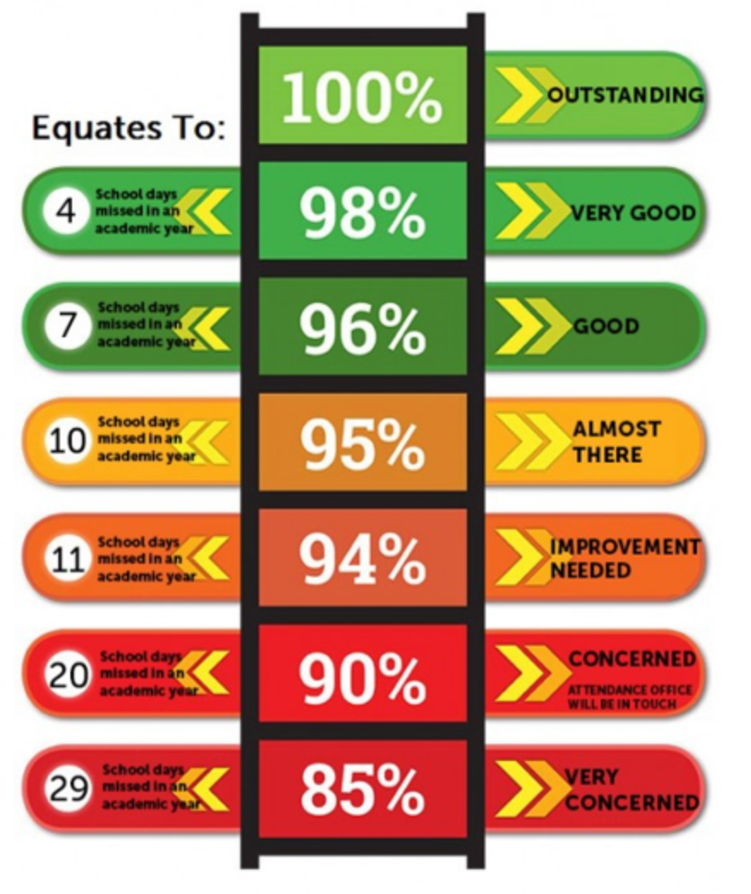

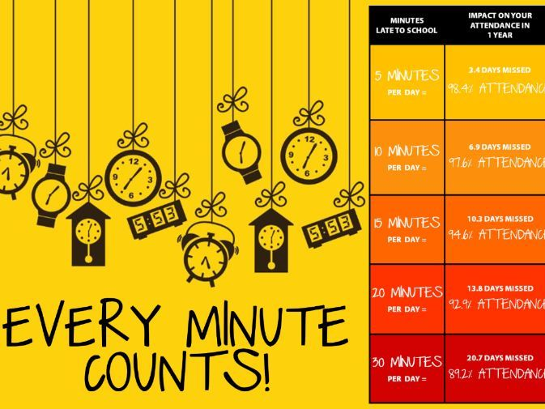

Appendix 4

Attendance Monitoring Procedures

At St Margaret of Scotland Catholic Primary School, we strongly believe that outstanding attendance is vital to ensuring that every child achieves their potential. Therefore, we constantly strive to improve and achieve an attendance of 96% or above.

100-96% | •Constant monitoring of attendance by Attendance Officer  •Certificates issued termly to celebrate 100% attendance  •Weekly rewards for classes in each Family with the highest attendance
95-89% | •Constant monitoring of attendance by Attendance Officer and Family Workers  •Regular monitoring by Education Welfare Officer  •Child encouraged to improve attendance by Class Teacher  •Letter sent to parents to inform them that attendance has dropped below 96%  •Support offered to parents with Attendance Officer or Family Worker
90-86%  Persistent Absentee | •Daily monitoring of attendance by school and Education Welfare Officer  •Parent invited to meet with Attendance Officer/Family Worker and Deputy Head  •Weekly records kept and parents informed if attendance improves or drops  •Home visit from Family Worker/Attendance Officer and Deputy Head if appropriate
85% & below  Persistent Absentee | •Education Welfare Officer will monitor attendance  •Request for medical evidence to be provided in order for absences to be authorised  •Fixed penalties and fast track to prosecution for those children/families that show no significant improvement actioned by EWO

Appendix 5

St. Margaret of Scotland Catholic Primary School
Headteacher: Mr S Chiswell
Rotheram Avenue, Luton LU1 5PP
Tel: 01582 723430
E-Mail: admin@stmargarets.luton.sch.uk
Website: www.stmargarets.luton.sch.uk

Date:

Dear Parent/Carer

Child’s Name:………………………………………………………………

This letter is to inform you that your child’s attendance has fallen below 96%, it is currently ………………..

96% and above is considered good attendance, this letter is just to make you aware of your child’s current attendance.

We know that illness happens occasionally, this cannot be helped and your child will need to stay at home to get better. There are also those days where it is not easy to decide if your child should be in school or not. We are happy for you to send your child in on these days as we will always contact parents if it is apparent that he/she is not well during the day.

If you would like to discuss any issues you are experiencing which may be impacting your child’s attendance please contact the school office and make an appointment to see either your child’s class teacher or one of the family workers.

We will continue to monitor your child’s attendance and look forward to seeing the improvement.

Yours sincerely

Miss K Conway
Attendance Officer

 |  |  |  | 
Appendix 6

St. Margaret of Scotland Catholic Primary School
Headteacher: Mr S Chiswell
Rotheram Avenue, Luton LU1 5PP
Tel: 01582 723430
E-Mail: admin@stmargarets.luton.sch.uk
Website: www.stmargarets.luton.sch.uk

Date:

Dear Parent/Carer

Child’s Name:……………………………………………………………………………..

This letter is to inform you that your child’s attendance has fallen below 90% which is classed as persistent absence.

Attendance is currently ……………………

Absence from school impacts learning so there is an urgent need for this to improve as your child’s education is being significantly affected.

We request that you come in to meet with myself and the Deputy Head so that we can discuss any issues you are experiencing which are impacting your child’s attendance. We can look at any support that could be offered so that attendance improves.

Can you please come to a meeting on ……………………………………………………. at ………………………….

Yours sincerely

Miss K Conway
Attendance Officer

Appendix 7

St. Margaret of Scotland Catholic Primary School
Headteacher: Mr S Chiswell
Rotheram Avenue, Luton LU1 5PP
Tel: 01582 723430
E-Mail: admin@stmargarets.luton.sch.uk
Website: www.stmargarets.luton.sch.uk

Date:

Dear

Child’s Name:

Number of lates:………………….. between …………………………… and ………………………….

………… minutes of learning lost.

This letter is to share our concerns with you about your child’s punctuality.

It is important that children arrive at school on time so that they are ready to start lessons at 8.30am.

When your child comes in late the lesson has already started and it disrupts the other children’s learning as the teacher has to stop the lesson in order to explain to your child.

Failure to improve punctuality will mean that a meeting will be arranged with you to discuss this further.

Please do not hesitate to contact the school if there is anything we can do to support you with your child’s punctuality.

Yours sincerely

Miss K Conway
Attendance Officer

Appendix 8

St. Margaret of Scotland Catholic Primary School
Headteacher: Mr S Chiswell
Rotheram Avenue, Luton LU1 5PP
Tel: 01582 723430
E-Mail: admin@stmargarets.luton.sch.uk
Website: www.stmargarets.luton.sch.uk

Date:

Dear

Child’s Name:

No. of lates:………………….. between …………………………… and ………………………….

Thank you for attending the meeting today to discuss your child’s punctuality.

As discussed it is so important that ………………………… arrives at school on time every day so that he/she is ready to start lessons at 8.30am.

We will continue to monitor punctuality and hope to see an improvement.

If for some reason there is no improvement we will have to refer to the EWO for further action and support.

Yours sincerely

Miss K Conway
Attendance Officer

The term parent includes those who have parental responsibility as defined in the Children Act 1989 and as defined in Section 576 of the Education Act 1996. The later gives parental responsibility to those who may not be the child’s actual parents but have day to day care of the child.

